**Project Planning Phase**

**Project Planning Template (Product Backlog, Sprint Planning, Stories, Story points)**

|  |  |
| --- | --- |
| Date | 26 June 2025 |
| Team ID | LTVIP2025TMID53148 |
| Project Name | ResolveNow: Your Platform for Online Complaints |
| Maximum Marks | 5 Marks |

# Product Backlog, Sprint Schedule, and Estimation (4 Marks)

**Functional Requirement User Story Story**

**Sprint User Story / Task Priority Team Members**

**(Epic) Number Points**

Sprint- As a user, I can register with email, password, and neelima, Team

Registration USN-1 2 High

1 confirmation. A

Sprint- As a user, I receive a confirmation email after

USN-2 1 High Varshitha

1 registration.

Sprint-

USN-3 As a user, I can register using Facebook. 2 Low Team B

2

Sprint-

USN-4 As a user, I can register using Gmail. 2 Medium Varshitha

1

Sprint-

Login USN-5 As a user, I can log in with my email and password. 1 High Team A

1

**Functional Requirement User Story Story**

**Sprint User Story / Task Priority Team Members**

**(Epic) Number Points**

Sprint- As a user, I can view my complaint status and

Dashboard USN-6 3 High Team C

1. history.

Sprint- As a user, I can submit a new complaint through a

Complaint Submission USN-7 3 High Team A

1. form.

Sprint-

Chat Feature USN-8 As a user, I can chat with the assigned agent. 4 High Team B

3

Sprint- As a user, I can rate and provide feedback after issue

Feedback System USN-9 2 Medium Team C

1. resolution.

# Project Tracker, Velocity & Burndown Chart (4 Marks)

**Project Tracker Table**

**Sprint Total Story Points Duration Sprint Start Date Sprint End Date (Planned) Story Points Completed Sprint Release Date (Actual)**

|  |  |  |  |  |  |
| --- | --- | --- | --- | --- | --- |
| Sprint-1 20 | 6 Days | 24 Oct 2022 | 29 Oct 2022 | 20 | 29 Oct 2022 |
| Sprint-2 20 | 6 Days | 31 Oct 2022 | 05 Nov 2022 | 18 (Estimated) | 05 Nov 2022 |
| Sprint-3 20 | 6 Days | 07 Nov 2022 | 12 Nov 2022 | 16 (Estimated) | 12 Nov 2022 |
| Sprint-4 20 | 6 Days | 14 Nov 2022 | 19 Nov 2022 | TBD | TBD |

# Velocity Calculation

**Formula:**

**Velocity = Total Story Points Completed / Number of Sprints**

* Sprint-1: 20
* Sprint-2: 18
* Sprint-3: 16
* Total Story Points = **54**
* Number of Sprints = **3**

**Team Velocity = 54 / 3 = 18 Story Points per Sprint**

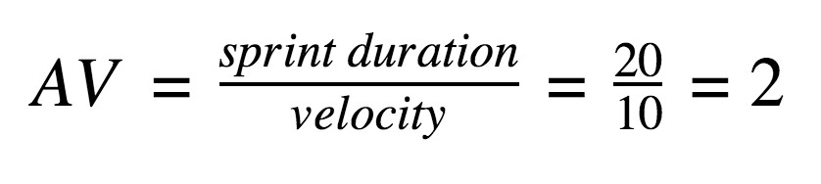

Team Velocity & Average Calculation

**Story Points Completed Per Sprint**

**Sprint Story Points Completed**

Sprint-1 20

Sprint-2 18

**Sprint Story Points Completed**

Sprint-3 16

**Total** **54**

**Average Story Points per Day**

Assuming each sprint = **6 working days**, then:

**Average = Velocity / Sprint Duration**

Average = 18 story points / 6 days = **3 story points per day**

# BURNDOWN CHART EXPLANATION

A **Burndown Chart** tracks the total remaining work (story points) against time (days). It helps monitor sprint progress and whether the team is on track to finish tasks within the sprint timeline.

* X-axis: Time (Sprint Days)
* Y-axis: Remaining Story Points
* Ideal line: Declines linearly from total points to zero
* Actual line: Shows real progress based on completed story points daily

## References

1. **Scrum Burndown Chart Overview** https://www.visual-paradigm.com/scrum/scrum-burndown-chart/
2. **Burndown Charts Tutorial** https://www.atlassian.com/agile/tutorials/burndown-charts
3. **Agile Project Management Guide** https://www.atlassian.com/agile/project-management
4. **How to Do Scrum with Jira Software** https://www.atlassian.com/agile/tutorials/how-to-do-scrum-with-jira-software
5. **Understanding Epics in Agile** https://www.atlassian.com/agile/tutorials/epics
6. **Introduction to Sprints** https://www.atlassian.com/agile/tutorials/sprints
7. **Agile Estimation Methods** https://www.atlassian.com/agile/project-management/estimation